UNIVERSITY OF IBADAN
DISTANCE LEARNING CENTRE (DLC)
DEPARTMENT OF COMPUTER SCIENCE
CSC 302: SYSTEM ANALYSIS AND DESIGN
GROUP PRACTICAL PROJECT — 2025/2026 SESSION
PROJECT TOPIC:
FLEET MANAGEMENT SYSTEM FOR A DELIVERY COMPANY:
(A CASE STUDY OF SMALL AND MEDIUM ENTERPRISES — SMEs)
GROUP NUMBER: 6
TEAM LEADER: IFEANYI OLUWADAMILOLA AGADA
GROUP MEMBERS
Full Name | Matric Number | Section(s) Contributed
OLADAPO MARIAM OLAJUMOKE | E051576 | Section 1.0
ONAOLAPO OYINDAMOLA ELIZABETH | E053414 | Section 2.0
AGADA OLUWADAMILOLA IFEANYI | E054583 | Section 3.1 - 3.4
OLUDARE OWOLABI AMOS | E053430 | Section 3.5 - 3.7
[Member 5 Full Name] | E000000 | Section 3.8 - 3.10
JIMOH NAFISAT ADEDOYIN | E055107 | Section 4.0 - 5.0

TABLE OF CONTENTS
Update this field to generate the table of contents.
1.0 INTRODUCTION
1.1 Background of the Study
1.2 Problem Statement
1.3 Aim and Objectives
1.4 Scope of the Study
1.5 Significance of the Study
2.0 LITERATURE REVIEW
2.1 Overview of Fleet Management Systems
2.2 Review of Existing Systems
2.3 Fleet Management Challenges Specific to Small Businesses
2.4 Gap in Existing Solutions and Justification for the Proposed System
3.0 SYSTEM ANALYSIS AND DESIGN
3.1 System Development Process Model
3.1.1 Analysis of the Existing System
3.1.2 Problems of the Existing System
3.1.3 Capabilities of the Proposed System
3.2 Feasibility Study
3.3 Requirements Determination
3.3.1 Requirements Elicitation Method and Case Scenario Basis
3.3.2 Functional Requirements
3.3.3 Non-Functional Requirements
3.4 Data Flow Diagrams (DFDs)
3.4.1 Activity Diagram
3.5 Entity-Relationship Diagram and Database Design
3.5.1 Class Model
3.5.2 Normalisation to Third Normal Form (3NF)
3.6 Use Case Diagram
3.6.1 Sequence Model
3.6.2 Structured English for Dispatch Allocation
3.6.3 Decision Table for Dispatch Allocation
3.7 System Design and Architecture
3.8 Interface Design: Input and Output Design
3.8.1 Input Design
3.8.2 Output Design
3.8.3 Design-Stage Interface Mock-ups
3.9 Program Design
3.9.1 Collaboration Diagram
3.9.2 State Machine Diagram
3.9.3 Flowchart
3.9.4 Pseudocode for Delivery Completion
3.10 Project Schedule (WBS and PERT/CPM)
4.0 SYSTEM IMPLEMENTATION AND TESTING
4.1 Development Tools and Technology Stack
4.1.1 Hardware and Software Requirements
4.2 Implementation Status
4.3 Planned Testing Strategy
5.0 SUMMARY, CONCLUSION AND RECOMMENDATIONS
5.1 Summary
5.2 Conclusion
5.3 Recommendations
REFERENCES
APPENDIX A: GROUP MEMBER CONTRIBUTIONS

1.0 INTRODUCTION

1.1 Background of the Study
Urban logistics in Nigeria relies heavily on small courier operators, independent e-commerce dispatch firms, and third-party delivery contractors running lean fleets of motorcycles, tricycles, and light delivery vans. In high-density commercial areas such as Lagos, these micro-logistics enterprises support last-mile fulfilment for retail vendors and direct consumers. Their coordination workflows are often manual, informal, and vulnerable to delays or incomplete information.
The operational context for this report is Case Organisation A, a constructed professional case scenario representing a small-scale dispatch and delivery operation in Lagos, Nigeria. The scenario models a business that receives jobs by phone call and WhatsApp, coordinates six regular riders across seven motorcycles (including one backup vehicle), and uses notebooks or chat messages for some delivery and maintenance records. It illustrates why a streamlined, affordable web system that centralises vehicle records, dispatches, delivery updates, and maintenance logs can be appropriate without imposing costly telematics hardware.

1.2 Problem Statement
Within the constructed Case Organisation A scenario, managing a delivery fleet through manual record-keeping creates operational vulnerabilities that the proposed system is intended to address:
- State Ambiguity: Dispatch managers cannot ascertain which vehicles are currently available in the depot, actively en route, or grounded for mechanical repairs, leading to frequent schedule clashes.
- Dispatch Bottlenecks: Lacking a centralized availability log, coordinators routinely assign urgent pickup orders to riders who are already committed to other delivery runs or off-shift.
- Blind Tracking: Delivery progress is tracked through sporadic phone calls rather than distinct state transitions (Pending -> In Progress -> Delivered), leaving customers and administrative staff uncertain of order status.
- Reactive Maintenance: Servicing is initiated only following mechanical breakdown rather than on scheduled calendar intervals, triggering avoidable vehicle downtime, missed delivery windows, and inflated workshop repair bills.
These interconnected deficits result in lost waybills, protracted customer disputes, inflated operating overhead, and damaged brand reputation. A structured systems intervention is necessary to replace fragmented paper ledgers with an integrated, auditable relational database platform.

1.3 Aim and Objectives
Aim: To analyse, model, design, and specify a computerised Fleet Management System that enables small and medium delivery enterprises to manage vehicle inventories, driver assignments, delivery lifecycles, and routine maintenance logs through an auditable, web-based platform.
Specific Objectives:
- Model and document the operational workflows represented by the Case Organisation A scenario, identifying the control gaps associated with manual record-keeping.
- Elicit and formulate comprehensive functional and non-functional requirements for an SME-targeted fleet management system using standard requirements-determination techniques.
- Model system process and data interactions using structured Data Flow Diagrams (Context Level and Level-0 DFD), adhering strictly to course balancing and process-decomposition rules.
- Develop an Entity-Relationship (ER) model and rigorously normalize the database relational schema from an unnormalized relation to Third Normal Form (3NF).
- Specify the behavioral use cases of the platform through UML use case modeling and establish a modular three-tier client-server software architecture.
- Formulate a detailed project implementation schedule using Work Breakdown Structure (WBS) decomposition and PERT/CPM critical path network analysis.
- Define an implementation and verification strategy encompassing multi-tier testing protocols and concrete test cases for all core functional modules.

1.4 Scope of the Study
This project focuses on the system analysis, relational database architecture, and software design specification of a Fleet Management System for a small delivery SME. Its baseline operational context is Case Organisation A, a constructed Lagos case scenario with six regular riders and seven motorcycles, including one backup vehicle. The design is scalable to a fleet of up to 50 vehicles. The operational boundary covers four primary functional modules: (1) Vehicle Registry and Real-Time Operational Status, (2) Rider/Driver Profiles with License Compliance Monitoring, (3) Delivery Order Creation, Vehicle-Rider/Driver Dispatching, and Multi-Stage Status Updates, and (4) Vehicle Maintenance Logging with Preventive Service Alerts and Administrative Fleet Dashboard Reporting.
The following aspects are explicitly excluded from the current baseline scope: continuous live GPS telematics hardware integration, automated vehicle routing algorithms, native mobile application binaries (the application is architected as a cross-platform responsive web application), automated point-of-sale banking payment gateways, and multi-tenant enterprise federation. These capabilities represent natural post-deployment enhancements detailed in Section 5.3.

1.5 Significance of the Study
Practical Significance: For the delivery enterprise, deploying this system eliminates dispatch guesswork, curbs fraudulent operational expense claims, reduces fleet downtime through structured maintenance logs, and restores operational accountability. Clear status pipelines give business owners immediate insight into fleet utilization and delivery execution.
Academic Significance: For the project team, this study serves as a practical demonstration of the systems analysis and software engineering principles taught in CSC 302—bridging theoretical concepts in process modeling, functional dependency analysis, relational database normalization (1NF -> 2NF -> 3NF), UML behavioral design, and PERT/CPM project scheduling into an end-to-end, engineering-grade technical deliverable.

2.0 LITERATURE REVIEW

2.1 Overview of Fleet Management Systems
Fleet management systems comprise an integrated suite of database tools, status tracking mechanisms, and workflow management services designed to coordinate commercial transport operations. In enterprise logistics, these systems integrate on-board telematics, electronic logging devices (ELD), satellite positioning (GPS), engine fault diagnostics, and dynamic route scheduling into a unified supervisory console (Locate2u, 2026). The central goal is to maximize vehicle operational availability, minimize total lifecycle fuel and maintenance costs, ensure legal regulatory compliance, and provide end-to-end auditability across the vehicle dispatch lifecycle.
While enterprise fleets justify multi-tiered operational telematics platforms, the economic and structural realities of micro and small delivery businesses necessitate a divergent engineering approach. For an enterprise operating five dispatch motorcycles and two light delivery vans, capital-intensive black-box telematics installations and recurring USD-denominated subscription contracts introduce disproportionate overhead (GlobalFleet, 2026). Consequently, recent systems literature emphasizes the design of lean, transaction-oriented fleet management architectures—platforms that prioritize rigorous relational record-keeping, driver allocation workflows, and scheduled maintenance notifications without relying on costly proprietary vehicle tracking hardware.

2.2 Review of Existing Systems
To establish a clear technical baseline, four established commercial fleet management platforms—spanning major international software suites and prominent indigenous solutions—were reviewed against the operating requirements of a Nigerian courier SME (Tech.co, 2026).
Table 2.1: Comparative Analysis of Existing Fleet Management Platforms vs. Small Delivery SME Baseline
System | Origin | Core Capabilities | Target Market | Key Limitation for Nigerian Delivery SMEs
Fleetio | United States | Vehicle lifecycle tracking, preventive maintenance automation, fuel card integrations, digital vehicle inspections. | Small to enterprise commercial fleets. | Per-vehicle monthly subscription billed in USD; assumes automated credit card billing and stable high-speed connectivity not guaranteed for lean local firms.
Samsara | United States | Real-time GPS telematics, AI dash-cam safety monitoring, driver coaching workflows, ELD hours-of-service compliance. | Medium to large haulage and long-distance transport fleets. | High upfront proprietary hardware requirements (GPS gateways, cameras); feature set far exceeds the administrative dispatch needs of local couriers.
Verizon Connect | United States | Live vehicle tracking, historical route replay, enterprise fuel reporting, driver behavior scorecards. | Enterprise fleets (20+ vehicles). | Quote-only enterprise contract pricing; protracted onboarding process and redundant compliance features irrelevant to lean intra-city couriers.
FleeTrak (Concept Nova) | Nigeria | Telematics tracking, fuel level monitoring, vendor management, scheduled maintenance reminders. | Broad Nigerian corporate sector (5 to 5,000+ vehicles). | Primarily positioned for corporate haulage and logistics conglomerates; pricing and onboarding workflows are not tailored for 2-to-10 vehicle dispatch couriers.

2.3 Fleet Management Challenges Specific to Small Businesses
Literature on commercial fleet logistics identifies operating frictions that can affect small-scale operators more sharply than larger firms because their capacity is limited (Cartrack South Africa, 2026; Universal Transit, 2026). For a small dispatch fleet, the temporary loss of one motorcycle can materially reduce available delivery capacity. Unscheduled repairs may also pressure cash flow by diverting funds from routine operating needs.
Many small fleet operators may have limited dedicated administrative support. A founder or supervisor may need to manage customer requests, delivery payments, rider schedules, and vehicle condition at the same time. This division of attention can contribute to oversights such as delayed servicing, incomplete licence records, or unclear delivery handover information.
Within the Nigerian commercial environment, fuel-price changes, traffic, and limited administrative controls can further complicate dispatch coordination. Industry commentary has highlighted the value of clearer records for monitoring vehicle use, fuel expenditure, and maintenance activities (BusinessDay, 2026; Techpoint Africa, 2026). A centralised operational database can help supervisors compare vehicle status, delivery assignments, and rider/driver availability more consistently.

2.4 Gap in Existing Solutions and Justification for the Proposed System
The comparative analysis reveals a distinct market failure: existing commercial software offerings cater to well-capitalized enterprises prepared to invest heavily in foreign software subscriptions and specialized telematics equipment, while local delivery SMEs remain abandoned to paper journals and informal messaging threads. This creates a critical engineering niche for a lightweight, web-native Fleet Management System designed specifically around the operational realities of Nigerian courier SMEs.
The proposed system bridges this structural gap by focusing exclusively on high-impact administrative core workflows: maintaining real-time operational status flags for vehicles and drivers, managing customer delivery waybills through a clear three-stage lifecycle, and logging routine workshop maintenance with cost metrics. By deploying modern open-source web technologies (Python Flask, SQLAlchemy ORM, PostgreSQL) on accessible cloud infrastructure, the system eliminates licensing and hardware barriers while delivering robust relational data integrity.

3.0 SYSTEM ANALYSIS AND DESIGN

3.1 System Development Process Model
This project adopts the classical Systems Development Life Cycle (SDLC) Waterfall methodology across its analytical and design phases: System Planning -> Requirements Analysis -> Architectural & Relational Design -> Implementation Specification and Verification Planning. While modern agile frameworks excel in commercial software environments characterized by volatile, rapidly shifting client specifications, the structured Waterfall approach was selected deliberately for this engineering project. The functional boundary and assessment criteria for the delivery SME case study are well-bounded, established upfront by curriculum directives, and require systematic verification at each intermediate modeling phase (requirements traceability, balanced DFD decompositions, 3NF mathematical normalization, and PERT/CPM schedule integrity) prior to downstream system construction.

3.1.1 Analysis of the Existing System
The existing-system findings below are derived from the constructed Case Organisation A scenario described in Section 3.3.1. In that scenario, the Operations/Dispatch Supervisor receives delivery requests by phone call or WhatsApp message, checks rider/driver availability informally through a WhatsApp group or direct call, assigns a rider/driver based on proximity and current workload, and records delivery and maintenance details in notebooks or scattered chat messages. The scenario suggests there is no single authoritative source of vehicle status, rider/driver availability, or delivery history; information is only as current as the last message exchanged.

3.1.2 Problems of the Existing System
The Case Organisation A scenario indicates several recurring operational problems. Rider/driver availability is not known in real time because it depends on someone remembering to send a WhatsApp update. Delivery status can be confirmed only by contacting the rider/driver, which becomes time-consuming when several deliveries are active. Vehicle maintenance history is scattered across memory, notebooks, and chat threads rather than centralised, making due servicing easier to miss. Lagos traffic compounds these issues by making actual location and availability harder to estimate from the last update.

3.1.3 Capabilities of the Proposed System
The proposed system centralises vehicle, rider/driver, customer, delivery, and maintenance records. It validates resource availability before dispatch, records delivery-state transitions, produces operational summaries, and supports proactive maintenance reminders. These controls are designed to support better scheduling, reduced downtime, and accountable fleet operations within the scenario.

3.2 Feasibility Study
A multi-dimensional feasibility assessment considers technical, economic, operational, and schedule factors using the operational findings from the constructed Case Organisation A scenario in Section 3.3.1.
Table 3.1: Multi-Dimensional System Feasibility Assessment Summary
Feasibility Dimension | Analytical Evaluation & Risk Assessment
Technical Feasibility | The proposed stack uses mature open-source technologies: Python 3, Flask, SQLAlchemy, and PostgreSQL. The Case Organisation A scenario assumes that riders/drivers and the supervisor already use Android smartphones and app-based communication, so a lightweight responsive web interface requires no specialised vehicle hardware. Verdict: Highly Feasible.
Economic Feasibility | Direct capital expenditure is limited because the proposed stack has no licence fee and low-cost hosting can support the Case Organisation A baseline of seven motorcycles and six regular riders. The scenario suggests that reducing duplicated dispatches, missed service information, and coordination calls could justify the modest hosting and training costs. Verdict: Highly Feasible.
Operational Feasibility | The proposed system digitises workflows that the Case Organisation A scenario already describes informally: recording a vehicle, logging a pickup address, checking availability, and confirming delivery. Because participants in the scenario already coordinate by smartphone, a simple dashboard and mobile view should require limited practical training, provided the interface remains clear and data-efficient. Verdict: Highly Feasible.
Schedule Feasibility | A rigorous critical path analysis (detailed in Section 3.10) demonstrates that the entire systems analysis, design, module implementation, testing, and report compilation lifecycle can be executed within 30 working days. This timeline aligns cleanly with academic course delivery windows. Verdict: Highly Feasible.

3.3 Requirements Determination
System requirements were derived primarily from the findings of the constructed Case Organisation A scenario in Section 3.3.1 and cross-checked against the contextual discussion in Section 2.3. This grounding establishes the functional requirements (FR) and non-functional constraints (NFR) in Sections 3.3.2 and 3.3.3. Each operational requirement is traceable to a scenario finding; NFR2 access control is included as a standard security design requirement.

3.3.1 Requirements Elicitation Method and Case Scenario Basis
For this coursework, requirements were elicited through a structured, scenario-based walkthrough. Because the project window did not permit access to a live commercial operator, the operating context is a constructed case scenario — referred to throughout this report as Case Organisation A — modelling a small motorcycle-based dispatch and delivery operation in Lagos, Nigeria. The scenario parameters (six regular riders, seven motorcycles including one dedicated backup unit, an average of 20–30 deliveries per day at peak, and a customer base composed of local online vendors, Instagram fashion brands, neighbourhood pharmacies and food vendors) are grounded in published industry commentary on Nigerian urban logistics and small-fleet operations (BusinessDay, 2026; GlobalFleet, 2026; Techpoint Africa, 2026) and in documented fleet-management frictions reported for small operators (Cartrack South Africa, 2026; Locate2u, 2026; Tech.co, 2026; Universal Transit, 2026).
The elicitation technique applied to the scenario follows the interview-guideline approach recommended in the CSC 302 course material (University of Ibadan Distance Learning Centre, 2026). A semi-structured guide comprising eight open questions was developed to interrogate the scenario. Each question probes a specific coordination activity: order intake, resource availability checking, status reporting, concurrent-job handling, vehicle record keeping, breakdown handling, dashboard intelligence, and usability constraints.
The responses recorded below are derived from the documented operating patterns cited above; they are not verbatim transcripts of a live interview. They are presented in question-and-answer form because this preserves direct traceability from each operational finding to the functional requirement it justifies.
Scenario Walkthrough Guide and Derived Responses
Q1. How are delivery requests usually received, and how do you decide which rider/driver gets each job?
- Scenario-derived response: Most requests come through our business phone line or WhatsApp. We manually note the pickup point, destination, customer contact, and item description. After that, we check the active rider WhatsApp group or call riders individually. We look at who is physically closest to the pickup point, who is free, and whether someone is already handling another package along that same route before assigning the job.
Q2. When a new order comes in, how do you check whether a rider/driver and motorcycle are actually available?
- Scenario-derived response: We don't have a live digital availability board or real-time tracker dashboard. We completely depend on the last text update dropped in the WhatsApp group, or we call the rider directly. A rider may look completely free in the chat group but might still be stuck waiting at a customer's pickup point or navigating back from a completed delivery. The supervisor has to get voice confirmation before assigning another order.
Q3. How do riders/drivers report that they have picked up an item, are on the way, or have completed delivery?
- Scenario-derived response: Riders usually type a quick WhatsApp message or place a call right after pickup and again immediately after dropping off the item. However, if they are stuck in intense Lagos traffic or running into weak data zones, updates come in late. The dispatch office then spends extra time calling the rider to get manual updates before we can give the customer a clear answer on where their package is.
Q4. What usually becomes difficult when several delivery jobs are running at the same time?
- Scenario-derived response: When we are handling high volumes simultaneously, it becomes incredibly easy to lose track of who is carrying what, which motorcycle is truly free, and which customer is waiting on a delayed delivery status. Lagos traffic patterns fluctuate instantly, shifting estimated times of arrival wildly. The supervisor can spend almost the entire day back-and-forth calling riders and updating clients instead of coordinating upcoming bookings.
Q5. How do you currently keep vehicle details and maintenance records for the motorcycles?
- Scenario-derived response: Vehicle identification details and service histories are fragmented—partly written in a paper notebook and partly saved across old chat logs. We record major mechanical repairs when they occur, but we lack a unified, comprehensive history for each motorcycle. This makes it very difficult to spot recurring vehicle issues or accurately predict when standard maintenance is due before a breakdown occurs.
Q6. If a motorcycle breaks down or is unavailable during work, what do you do with the rider/driver and the customer’s delivery?
- Scenario-derived response: If a bike develops a sudden fault on the road, our first step is checking if the rider can pull over safely and if we have another nearby rider who can intercept and transfer the package. Our backup motorcycle is utilized when it's available in the yard; otherwise, the supervisor has to hail an external dispatch rider or call the customer to explain the delay. These incidents and tracking the downstream repair expenses are rarely documented in a single repository.
Q7. What information would help you most on a daily dashboard?
- Scenario-derived response: The dispatch office needs a single screen that shows which motorcycles and riders are available, en route, or grounded for maintenance. It should highlight active job counts, flag delayed shipments, and track upcoming service deadlines. A clear, consolidated summary of daily completed deliveries and maintenance costs would instantly streamline our operational decisions.
Q8. What would make a digital system easy or difficult for your team to use?
- Scenario-derived response: The interface has to be incredibly lightweight and optimized for standard Android mobile phones. Riders will strongly resist any platform that consumes too much internet data, requires multi-step procedures, or freezes when network signals drop. Big, clear action buttons and simple status selection toggles are mandatory to make adoption smooth for field workers.
Summary of Findings
The Case Organisation A scenario models a fleet operations framework consisting of six active riders and seven motorcycles (including one dedicated backup unit), managing an average of 20–30 daily deliveries during peak operations. Its core customer base is composed of localized SMEs, including online vendors, Instagram fashion brands, neighborhood pharmacies, and food vendors.

The derived operating patterns show that operations of this type rely heavily on manual coordination via phone calls and WhatsApp groups. Allocation is limited by fragmented communication, status verification demands constant phone calls, and fleet maintenance tracking remains unautomated. Inconsistent network connectivity and dynamic Lagos traffic exacerbate these operational friction points.

Consequently, the definitive system requirements derived from this elicitation include:
- Availability Management
- Delivery Allocation
- Status Updates & Notifications
- Maintenance Logging & Fleet Reminders
- Role-Based Access Control
- Dashboard Reporting
- Data-Efficient, Responsive Mobile UI

Methodology Note: In this project text, the terms ‘rider’ and ‘driver’ are used interchangeably to represent the field personnel operating the delivery motorcycles; the exact database schema label Driver is strictly preserved where referenced in architectural data models and backend diagrams.

3.3.2 Functional Requirements
Table 3.2: Formal Functional Requirements Specification
Requirement ID | Functional Capability & System Behavior Specification
FR1: Vehicle Asset Management | The system shall provide authenticated administrative users with interfaces to register, modify, view, and retire vehicle asset records, capturing registration plate number, vehicle make, model, category (Bike, Trike, Van), initial odometer reading, and operational availability status.
FR2: Rider/Driver Registry Management | The system shall allow administrators to create, update, and query rider/driver profiles, recording full name, phone contact, driver licence number, licence expiration date, and active availability status.
FR3: Delivery Order Ingestion | The system shall record incoming delivery order requests from or on behalf of customers, persisting sender identity, recipient details, pickup address, drop-off destination address, line-item descriptions, and creation timestamp.
FR4: Dispatch Allocation Engine | The system shall provide administrative dispatchers with an allocation workflow to assign an available vehicle and an available rider/driver to a pending delivery order, verifying resource availability before assignment confirmation.
FR5: Rider/Driver Lifecycle Status Updates | The system shall provide dispatch riders/drivers with a dedicated mobile-responsive interface to update the execution status of assigned deliveries across discrete sequential stages: Pending -> In Progress -> Delivered (or Cancelled).
FR6: Preventive Maintenance Logging | The system shall enable administrative users to record vehicle service events against specific vehicle assets, capturing service date, odometer reading, workshop work description, spare parts cost, and projected next service due date.
FR7: Dynamic Resource State Enforcement | The system shall automatically transition the operational status of an allocated vehicle and rider/driver to 'On Delivery' upon job assignment, and automatically restore both assets to 'Available' upon delivery completion, preventing double-allocation conflicts.
FR8: Operational Intelligence Dashboard | The system shall aggregate relational records into real-time managerial summary metrics, displaying total active fleet counts, asset utilization rates, driver availability breakdowns, active delivery counts by stage, and maintenance expenditure totals.
FR9: Delivery Event Notifications | The system shall notify relevant users (administrators, assigned driver, and customer where applicable) of key delivery-lifecycle events — assignment, pickup, completion, or delay — directly addressing the interview finding that delivery progress can currently only be confirmed by directly calling the rider.

3.3.3 Non-Functional Requirements
Table 3.3: System Non-Functional Requirements & Architectural Constraints
NFR ID | Quality Attribute | Quantitative Acceptance Metric & Architectural Constraint
NFR1 | Performance & Latency | The system shall process and return responses for relational status queries (vehicle, driver, and delivery state queries) within 3.0 seconds under nominal network conditions (< 20 concurrent sessions).
NFR2 | Access Control & Security | Administrative management actions (adding/deleting vehicles, modifying driver profiles, approving maintenance logs) shall be restricted strictly to authenticated administrators using encrypted password hashes (bcrypt/pbkdf2).
NFR3 | Ergonomics & Usability | The user interface shall be designed with high affordance such that administrative operators and dispatch drivers can successfully log an order or update trip status without requiring external technical user manuals.
NFR4 | Data Integrity & Durability | The database tier shall strictly enforce ACID transaction guarantees, maintaining referential foreign key integrity without data loss, orphan records, or silent record degradation during concurrent updates.
NFR5 | Horizontal Scalability | The relational schema architecture shall support scaling from an initial lean deployment of 7 operational vehicles up to at least 50 operational vehicles and 5,000 historical delivery orders without necessitating schema modifications.
NFR6 | Cross-Device Portability | The frontend web interface shall render responsively across modern desktop browsers and mobile web clients (Safari, Chrome, Firefox) without requiring native device runtime dependencies.
NFR7 | Data Efficiency | Mobile interactions shall minimise data payload size, reflecting the interview finding that riders operate on mobile data with occasionally inconsistent connectivity while on the road.

3.4 Data Flow Diagrams (DFDs)
System process logic and boundary data interactions are modeled using structured Data Flow Diagrams conforming to standard Gane and Sarson notation. Process modeling proceeds hierarchically from a top-level Context Diagram (Process 0) to a fully balanced Level-0 decomposition.
Figure 3.1 illustrates the Context Diagram. The system is represented as a single central process entity (Process 0.0: Fleet Management System) interacting with three primary external entities: CUSTOMER, DRIVER / RIDER, and FLEET MANAGER (ADMIN). Net boundary data flows capture all incoming requests and outgoing status notifications without exposing internal datastores.
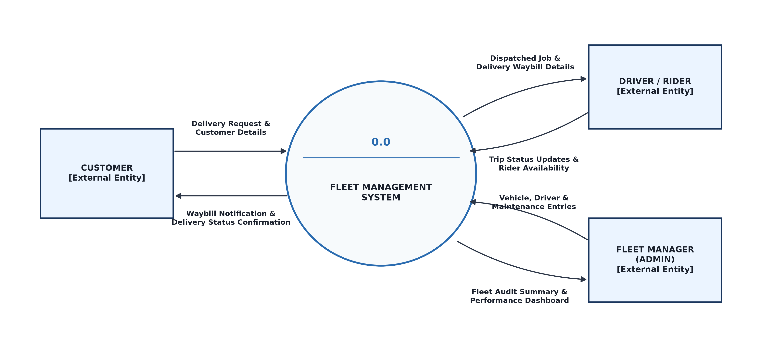
Figure 3.1: Context Data Flow Diagram (Process 0.0: Fleet Management System)
To model internal subsystem behavior, Process 0.0 is decomposed into seven cooperating sub-processes and five persistent data stores, displayed on the subsequent landscape page. The decomposition strictly adheres to the four fundamental DFD syntax and balancing rules covered in systems analysis:
1. Store-to-Store Prohibition: No data flow travels directly between two data stores; all store interactions are mediated by a process.
2. Entity-to-Store Prohibition: External entities cannot directly read from or write to persistent data stores; all interactions flow through an intermediate validating process.
3. Entity-to-Entity Prohibition: Communication between external entities is external to the system boundary and does not appear on the diagram.
4. Process Completeness & Conservation of Data: Every process maintains at least one incoming input data flow and at least one outgoing output data flow (preventing 'black hole' sinks or 'miracle' generation anomalies).

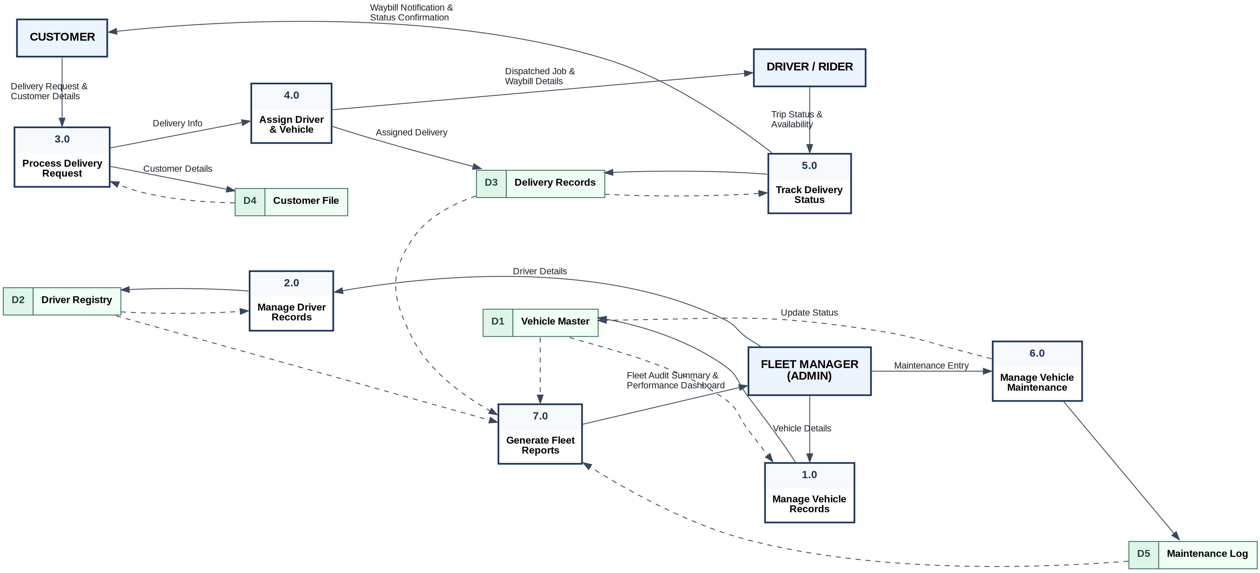
Figure 3.2: Level-0 Data Flow Diagram Decomposition (Processes 1.0 to 7.0 & Stores D1 to D5)

3.4.1 Activity Diagram
The activity diagram in Figure 3.3 models the operational flow from receiving a delivery request to confirming successful completion. A dispatch can proceed only when a driver and vehicle are both available; otherwise, the system presents an allocation-conflict message and retains the order as pending.
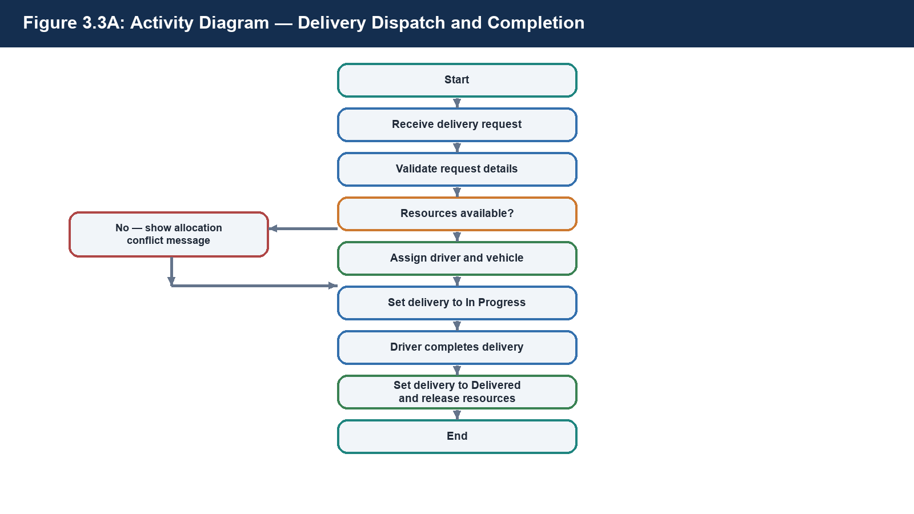
Figure 3.3: Activity Diagram — Delivery Dispatch and Completion

3.5 Entity-Relationship Diagram and Database Design
The conceptual data model captures the essential domain entities, their identifying attributes, and their operational relationships. The model comprises seven core entities: CUSTOMER, DRIVER, VEHICLE, DELIVERY, MAINTENANCE_LOG, PRODUCT, and the associative junction entity DELIVERY_ITEM. Figure 3.4 illustrates the Entity-Relationship Diagram rendered using Information Engineering (Crow's Foot) notation.
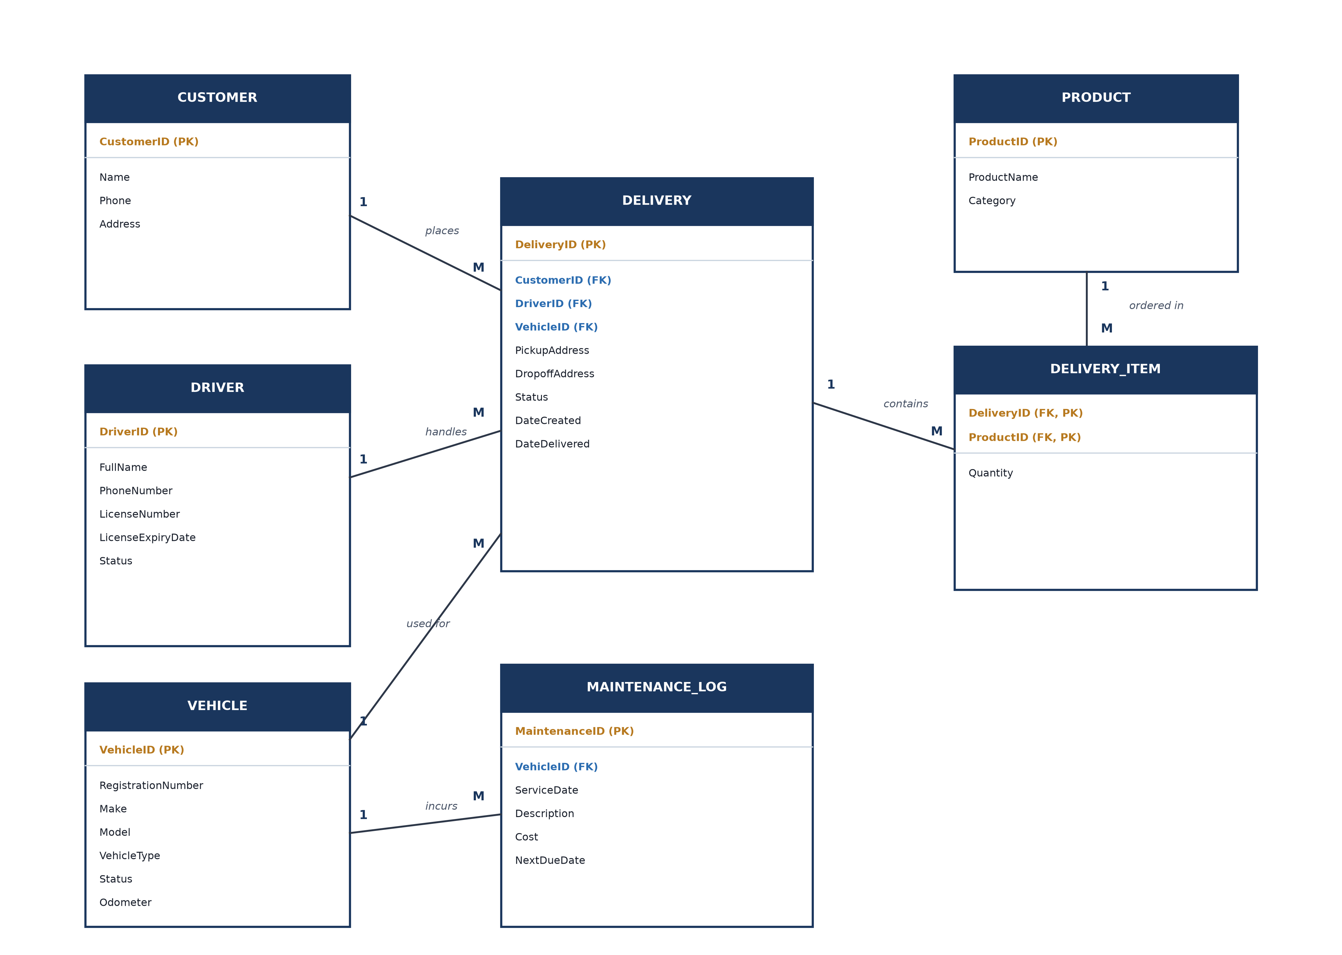
Figure 3.4: Entity-Relationship Diagram (Crow's Foot Relational Notation)
To model order line items without data duplication, the conceptual Many-to-Many (M:N) relationship between DELIVERY and PRODUCT is formally resolved via the associative entity DELIVERY_ITEM. This transforms the M:N association into two clean One-to-Many (1:M) relationships (DELIVERY 1 -> M DELIVERY_ITEM and PRODUCT 1 -> M DELIVERY_ITEM). The primary keys of both parent relations are migrated into DELIVERY_ITEM to form its composite primary key (DeliveryID, ProductID), with Quantity positioned as an intersection attribute characterizing the specific line-item instance.

3.5.1 Class Model
The class model supplements the ER diagram by representing the core software-domain objects, their key attributes, and their associations. Delivery is the central transactional class: a customer places deliveries, each delivery is allocated to a driver and vehicle, it contains one or more delivery items, and a vehicle accumulates maintenance logs.
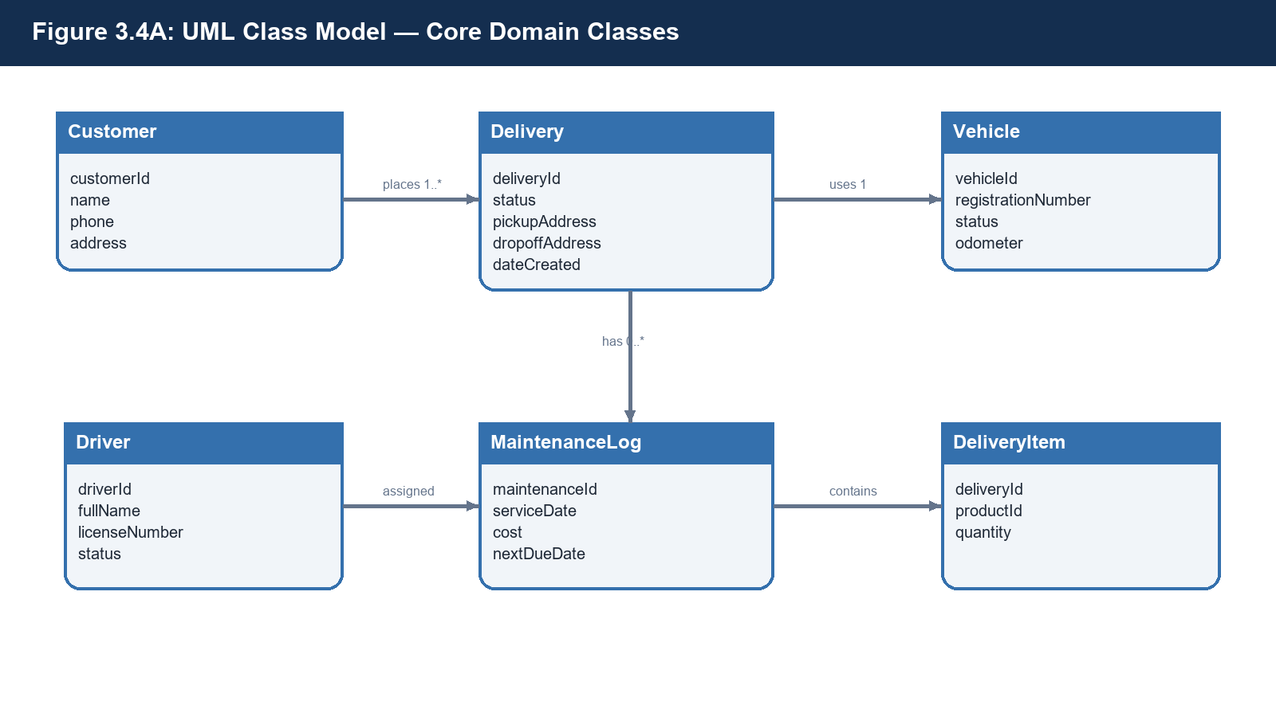
Figure 3.5: UML Class Model — Core Domain Classes

3.5.2 Normalisation to Third Normal Form (3NF)
To guarantee relational integrity, eliminate data anomalies (insertion, deletion, and modification anomalies), and minimize storage redundancy, the schema was derived through formal normalization from an unnormalized relation to Third Normal Form (3NF).
Consider an initial flat, unnormalized delivery ledger record combining customer, vehicle, driver, and product attributes into a single relation:
UNNORMALIZED_DELIVERY (DeliveryID, CustomerName, CustomerPhone, CustomerAddress, DriverName, DriverPhone, DriverLicense, VehicleRegNo, VehicleMake, VehicleType, PickupAddress, DropoffAddress, Status, DateCreated, ProductName, ProductCategory, Quantity)
Because a single delivery order may contain multiple distinct products, the candidate key for this composite relation is (DeliveryID, ProductName).
First Normal Form (1NF) Evaluation: A relation is in 1NF if and only if all attribute values are atomic (non-decomposable) and there are no repeating groups. Assuming all multi-valued item lists are flattened such that each tuple holds atomic values under the composite primary key (DeliveryID, ProductName), the relation satisfies 1NF.
Second Normal Form (2NF) Transformation: A relation is in 2NF if it is in 1NF and every non-prime attribute is fully functionally dependent on the entire primary key, thereby eliminating partial functional dependencies (where a non-key attribute depends on only part of a composite key). Evaluating functional dependencies across UNNORMALIZED_DELIVERY:
DeliveryID -> CustomerName, CustomerPhone, CustomerAddress, DriverName, DriverPhone, DriverLicense, VehicleRegNo, VehicleMake, VehicleType, PickupAddress, DropoffAddress, Status, DateCreated
ProductName -> ProductCategory
(DeliveryID, ProductName) -> Quantity
Notice that attributes such as CustomerName, DriverName, and VehicleRegNo depend solely on DeliveryID (a proper subset of the primary key), not on ProductName. Similarly, ProductCategory depends solely on ProductName. These partial dependencies severely violate 2NF. Decomposing the relation eliminates these partial dependencies by separating line items into DELIVERY_ITEM (DeliveryID, ProductID, Quantity) where Quantity depends on the full composite key, extracting PRODUCT (ProductID, ProductName, Category), and isolating core delivery data into a relation keyed on DeliveryID.
Third Normal Form (3NF) Transformation: A relation is in 3NF if it is in 2NF and no non-prime attribute is transitively dependent on the primary key (i.e., for every non-trivial functional dependency X -> Y, either X is a superkey or Y is a prime attribute). Within the isolated delivery relation keyed on DeliveryID, transitive dependencies persist:
DeliveryID -> CustomerID, and CustomerID -> CustomerName, CustomerPhone, CustomerAddress (Transitive Dependency)
DeliveryID -> DriverID, and DriverID -> DriverName, DriverPhone, DriverLicense (Transitive Dependency)
DeliveryID -> VehicleID, and VehicleID -> VehicleRegNo, VehicleMake, VehicleType (Transitive Dependency)
In each instance, non-key attributes depend on intermediate foreign keys (CustomerID, DriverID, VehicleID) rather than directly on the relation's primary key (DeliveryID). Resolving these transitive dependencies requires decomposing the delivery relation into dedicated relations: CUSTOMER, DRIVER, and VEHICLE, leaving only foreign key references inside the final DELIVERY relation.
The resulting relational schema satisfies Third Normal Form (3NF) without exception: all attributes are atomic, all non-key attributes are fully dependent on the primary key, and no transitive dependencies remain.
Table 3.4: Final 3NF Normalized Relational Database Schema Specification
Normalized Relation | Attributes & Relational Constraints (PK: Primary Key, FK: Foreign Key)
CUSTOMER | CustomerID (PK), Name, Phone, Address
DRIVER | DriverID (PK), FullName, PhoneNumber, LicenseNumber, LicenseExpiryDate, Status
VEHICLE | VehicleID (PK), RegistrationNumber, Make, Model, VehicleType, Status, Odometer
DELIVERY | DeliveryID (PK), CustomerID (FK), DriverID (FK), VehicleID (FK), PickupAddress, DropoffAddress, Status, DateCreated, DateDelivered
DELIVERY_ITEM | DeliveryID (FK, PK), ProductID (FK, PK), Quantity
PRODUCT | ProductID (PK), ProductName, Category
MAINTENANCE_LOG | MaintenanceID (PK), VehicleID (FK), ServiceDate, Description, Cost, NextDueDate

3.6 Use Case Diagram
System behavioral dynamics and user interaction boundaries are modeled via UML Use Case specifications. The system establishes interactions across three core actors: the Customer, the Dispatch Rider / Driver, and the Administrative Fleet Manager. Figure 3.6 depicts the Use Case Diagram rendered with explicit UML 2.5 stereotypes.
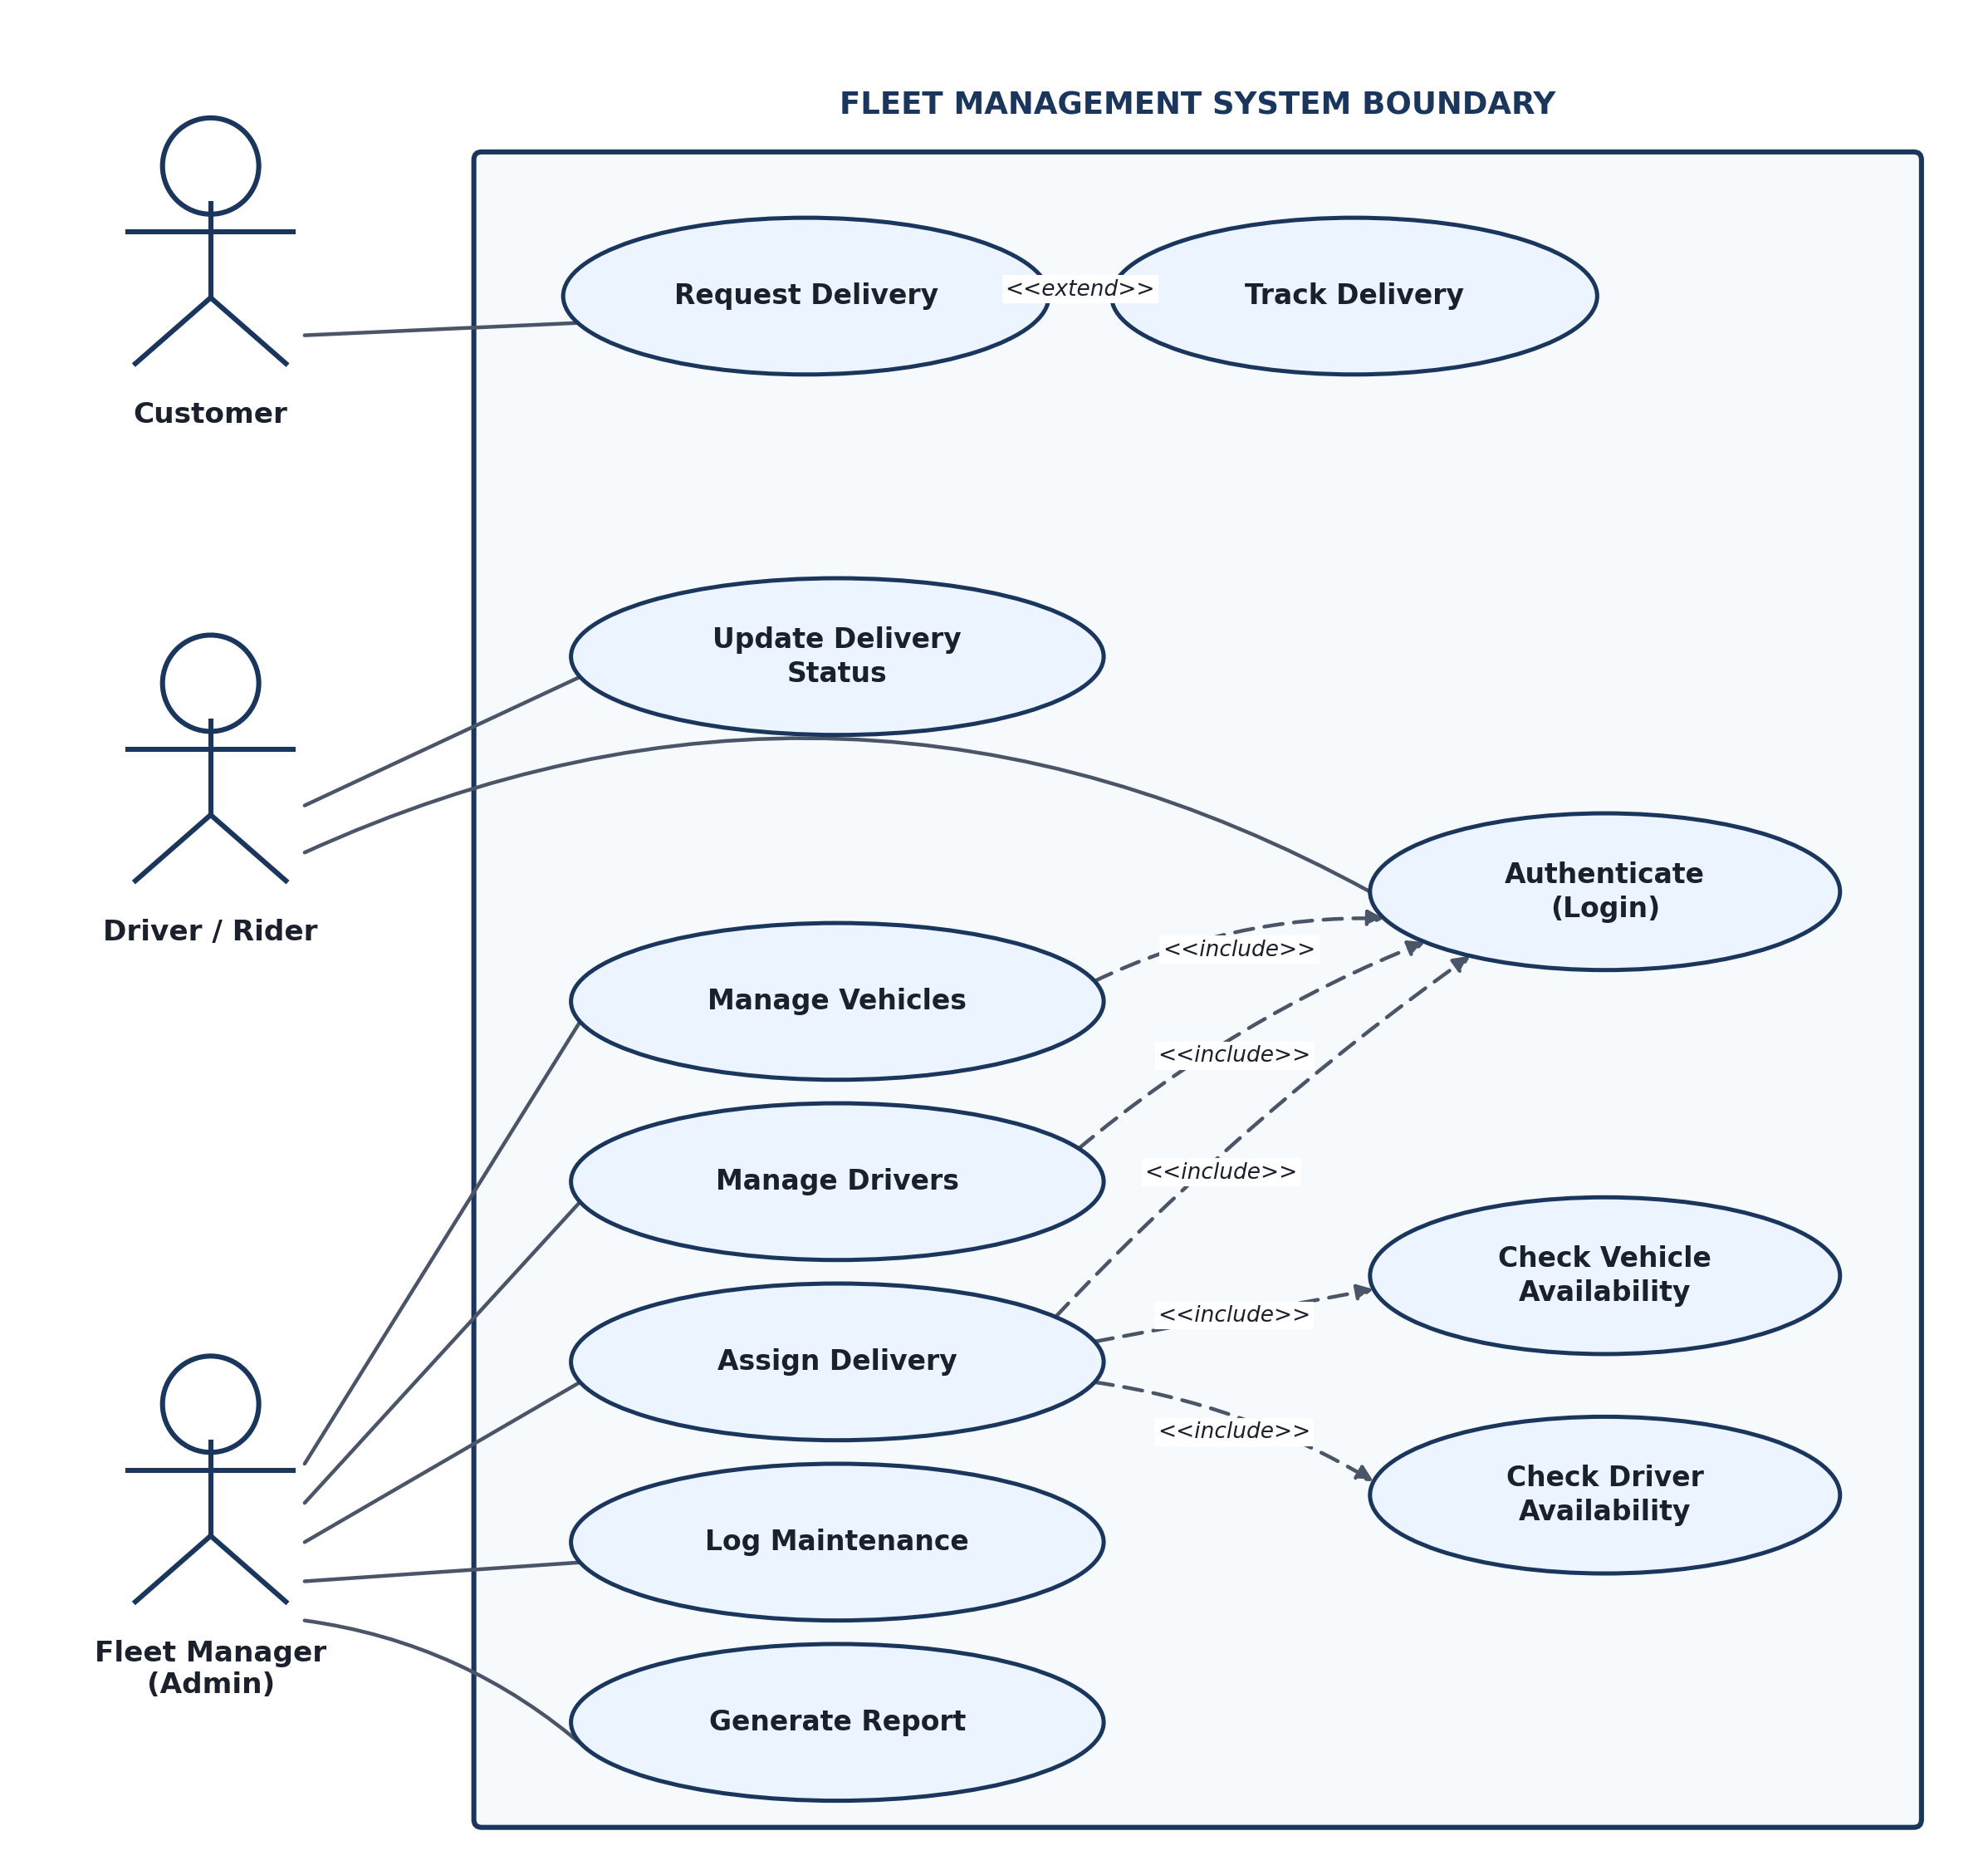
Figure 3.6: UML Use Case Diagram (Actor Roles and System Boundary Interactions)
The model incorporates distinct dependency semantics: the 'Assign Delivery' use case unconditionally incorporates both 'Check Vehicle Availability' and 'Check Driver Availability' via <<include>> relationships, ensuring that dispatchers cannot commit an assignment without system-verified resource readiness. Conversely, 'Track Delivery' is modeled with an <<extend>> relationship to 'Request Delivery', capturing optional downstream monitoring initiated at the discretion of the customer.

3.6.1 Sequence Model
Figure 3.7 shows the time-ordered interaction that occurs when an administrator allocates a delivery. The application service checks the database for available resources, creates the assignment and state updates within one transaction, notifies the driver, and returns confirmation to the interface.
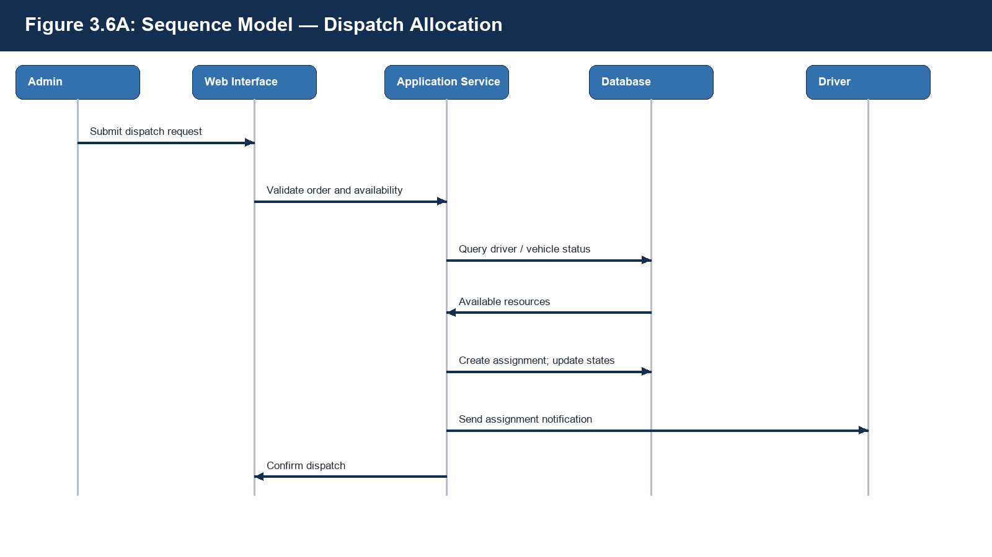
Figure 3.7: Sequence Model — Dispatch Allocation

3.6.2 Structured English for Dispatch Allocation
BEGIN
RECEIVE delivery ID, driver ID, and vehicle ID
IF delivery status is not Pending THEN display “Delivery cannot be assigned”
ELSE IF driver status is not Available OR vehicle status is not Available THEN display “Selected resource is unavailable”
ELSE
create delivery assignment
set delivery status to In Progress
set driver status to On Delivery
set vehicle status to On Delivery
save all changes as one transaction
notify assigned driver
END IF
END

3.6.3 Decision Table for Dispatch Allocation
Table 3.5 defines the decision logic used by the allocation service. It prevents an incomplete order or an unavailable vehicle/driver from being committed as an active dispatch.
Table 3.5: Decision Table for Dispatch Allocation
Conditions / Actions | Rule 1 | Rule 2 | Rule 3 | Rule 4
Delivery is Pending | Y | Y | Y | N
Driver is Available | Y | N | Y | –
Vehicle is Available | Y | Y | N | –
Create assignment | Y | N | N | N
Show availability error | N | Y | Y | N
Show invalid-status error | N | N | N | Y

3.7 System Design and Architecture
The software follows a modern three-tier client-server architectural paradigm rather than an obsolete file-server model. In a file-server architecture, database files must be transmitted in bulk across local network wires to client workstations for localized query evaluation—incurring prohibitive network traffic, severe locking contention, and high data corruption risks. The three-tier client-server architecture cleanly separates responsibilities across Presentation, Application Logic, and Relational Persistence tiers, as depicted in Figure 3.8.
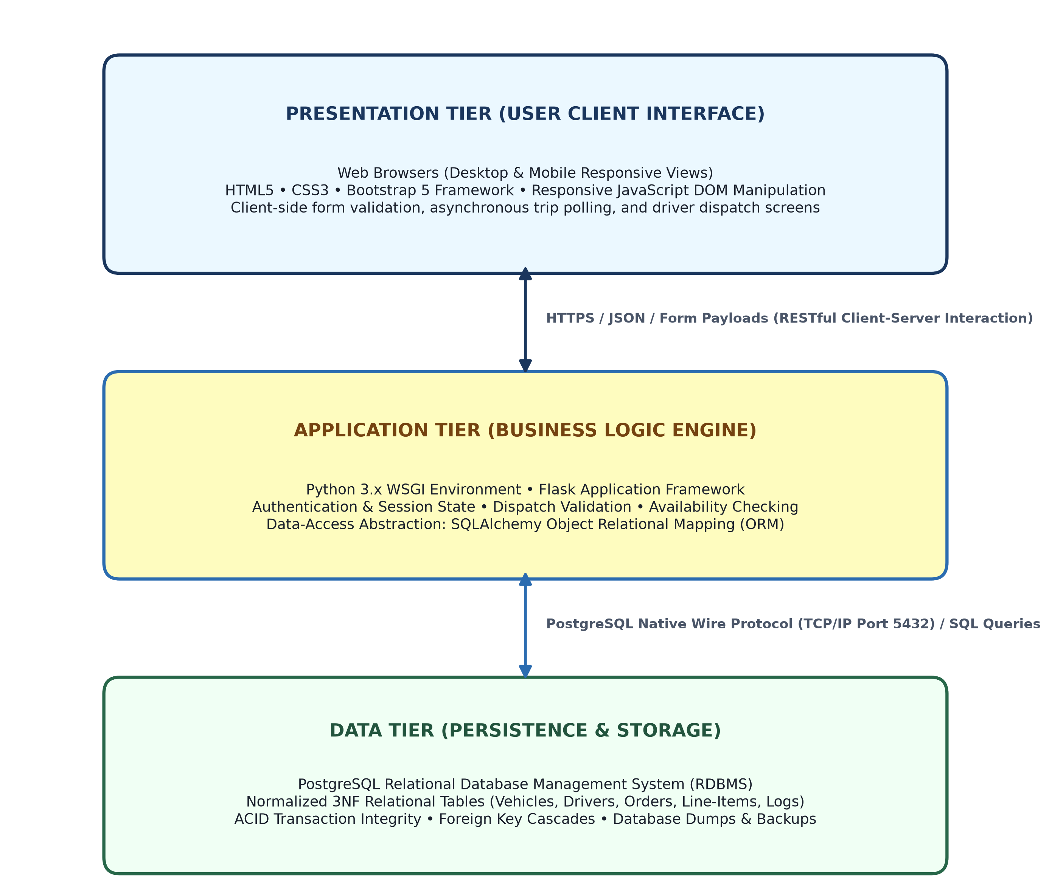
Figure 3.8: Three-Tier Client-Server Software Architecture
1. Presentation Tier (Client): Lightweight HTML5, CSS3, Bootstrap 5, and JavaScript executed natively in client web browsers across desktop and mobile devices. Manages DOM manipulation, interactive status tables, and form submission via HTTPS.
2. Application Tier (Web & Business Logic): Python 3 runtime hosting the Flask micro-framework. Encapsulates authentication middleware, dispatch allocation logic, availability validation rules, and the SQLAlchemy ORM abstraction layer.
3. Data Tier (Relational Storage): PostgreSQL relational database engine running dedicated database server processes. Enforces ACID guarantees, relational foreign key constraints, indexing, and persistent transaction logging.

3.8 Interface Design: Input and Output Design
The user interface is structured around a streamlined, responsive navigation layout. In accordance with the functional requirements and use case definitions, the system specifies seven primary user interface screens. Each screen is tailored to the operational role of the interacting actor, maximizing data visibility while enforcing strict form input validation.
Table 3.6: Master Screen Inventory and User Interface Specification
Interface Screen | Functional Objective & Operational Role | Primary User Interface Controls & Input Elements
Login & Authentication | Authenticates administrative managers and dispatch drivers; initializes secure session state. | Username/Email input field, masked password entry, role-aware submit button, validation alerts.
Operations Dashboard | Provides managerial at-a-glance visibility into real-time fleet operations and status distributions. | Vehicle availability summary cards, driver roster status badges, delivery counts by lifecycle stage, critical maintenance alerts.
Vehicle Asset Console | Enables administrators to view, register, edit, and inspect physical vehicle fleet records. | Filterable asset datatable, modal 'Register New Vehicle' form, status toggles (Available / On Delivery / In Maintenance), mileage log.
Driver Management Console | Manages driver and rider rosters, contact records, and statutory license compliance. | Driver roster table, license expiry highlight badges, 'Enroll Driver' form, status toggles (Available / On Delivery / Off Duty).
Dispatch Allocation Screen | Facilitates delivery order intake and coordinates driver/vehicle allocation. | Customer address input fields, cargo description, available vehicle dropdown, available driver dropdown, assignment confirmation button.
Driver Execution Screen (Mobile) | Empowers dispatch riders to review trip waybills and record status milestones in the field. | Assigned delivery waybill details, recipient contact click-to-call button, one-touch state advance buttons ('Start Trip', 'Confirm Delivery').
Maintenance Logging Screen | Captures mechanical repair events, workshop descriptions, and cost expenditures. | Vehicle selector dropdown, workshop service date picker, expenditure numeric field, repair description textarea, next service due date.

3.8.1 Input Design
Input forms are designed to collect accurate, complete, and validated data. Mandatory fields are marked clearly, date and numeric controls constrain format, and selection lists prevent inconsistent status values. The following proposed forms demonstrate how vehicle and dispatch records are captured.
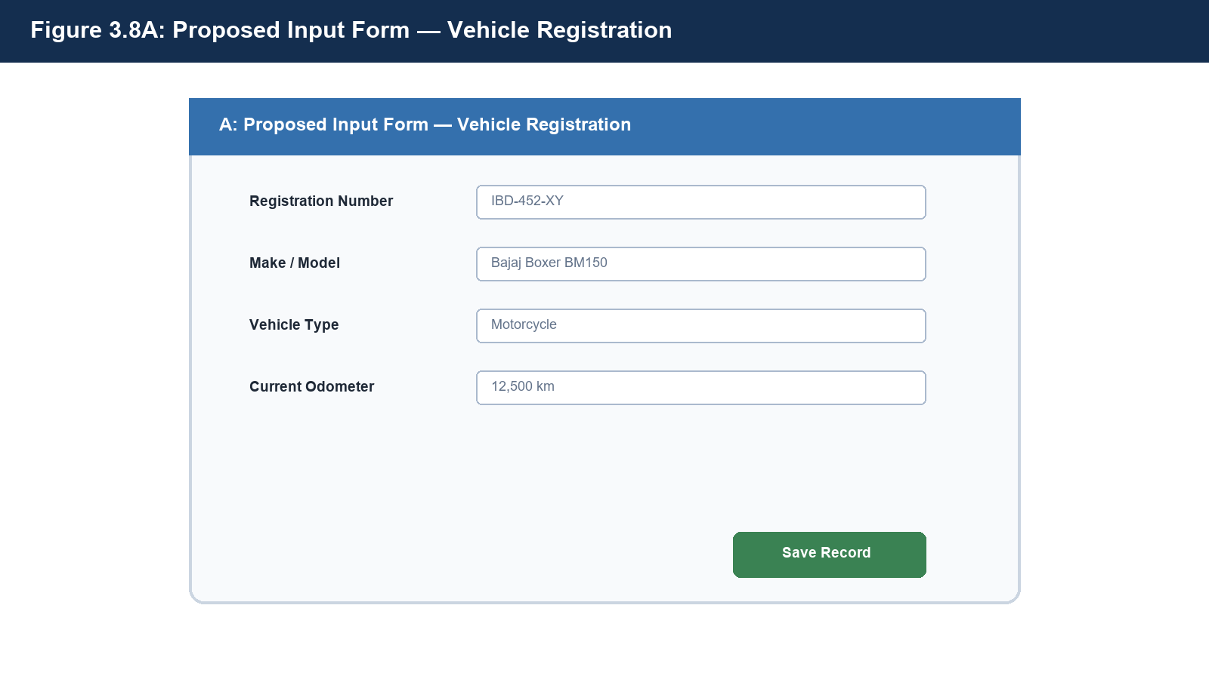
Figure 3.9: Proposed Input Form — Vehicle Registration
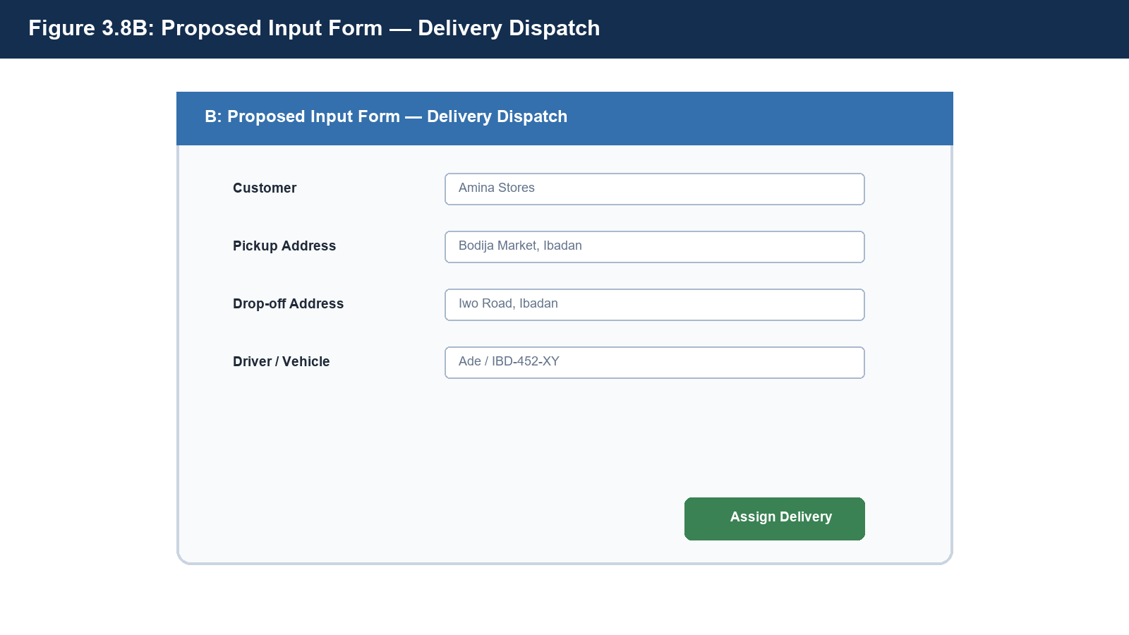
Figure 3.10: Proposed Input Form — Delivery Dispatch

3.8.2 Output Design
Output screens provide concise, decision-ready information. The fleet dashboard summarizes vehicle availability, active deliveries, driver utilisation, and upcoming maintenance work. Detailed reports may be filtered by date, vehicle, driver, or delivery status and exported when implemented.
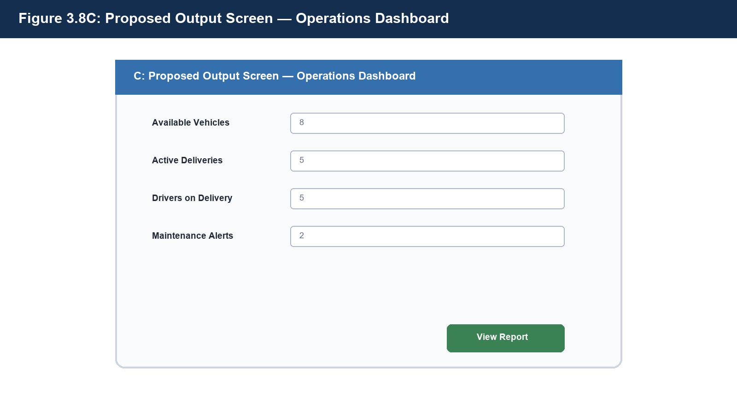
Figure 3.11: Proposed Output Screen — Operations Dashboard Report

3.8.3 Design-Stage Interface Mock-ups
Figures 3.9 to 3.11 are design-stage interface mock-ups produced as part of the interface specification, before code construction. They define the intended screen layout, input controls, validation behaviour and report presentation for the corresponding screens listed in Table 3.6.

3.9 Program Design
Program design translates the analysis models into implementable control logic. The following collaboration, state machine, and flowchart diagrams show how the dispatch components collaborate, how delivery status is constrained, and how maintenance alerts are derived. Together, they guide implementation and test-case design.

3.9.1 Collaboration Diagram
The collaboration diagram identifies the participating objects and numbered messages used to coordinate a dispatch allocation. It complements the sequence model by emphasizing the relationships among the objects rather than time alone.
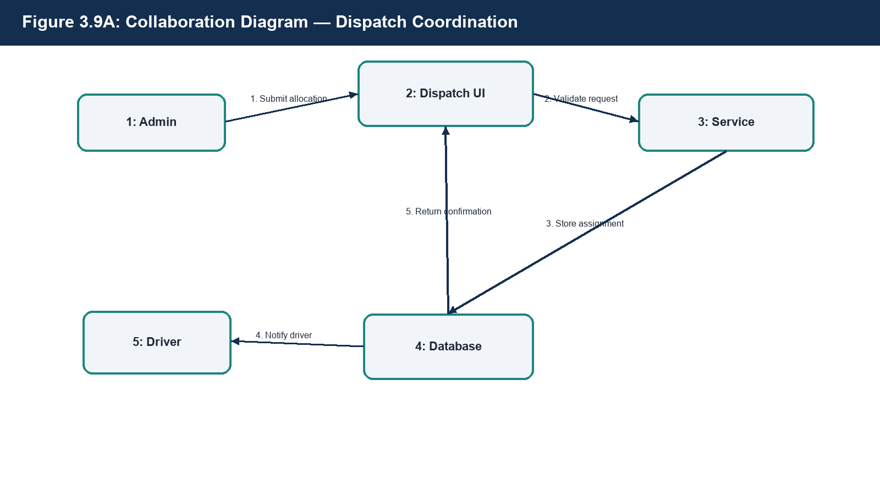
Figure 3.12: Collaboration Diagram — Dispatch Coordination

3.9.2 State Machine Diagram
The delivery state machine prevents invalid status changes. A pending delivery may be allocated and started, an in-progress delivery may be completed, and cancellation is permitted only before final completion according to business policy.
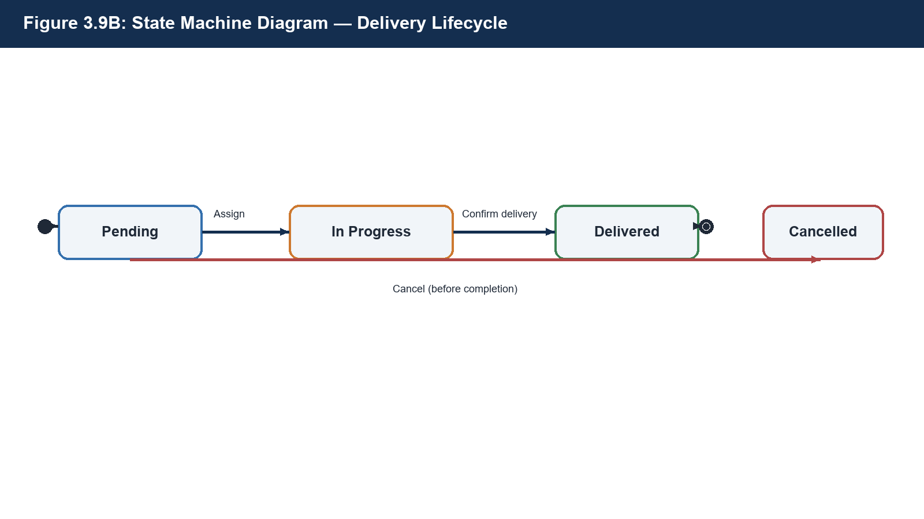
Figure 3.13: State Machine Diagram — Delivery Lifecycle

3.9.3 Flowchart
The flowchart specifies the preventive-maintenance alert routine. At scheduled checks, the system compares the current date and odometer readings against the next service threshold and notifies the fleet manager when service is due.
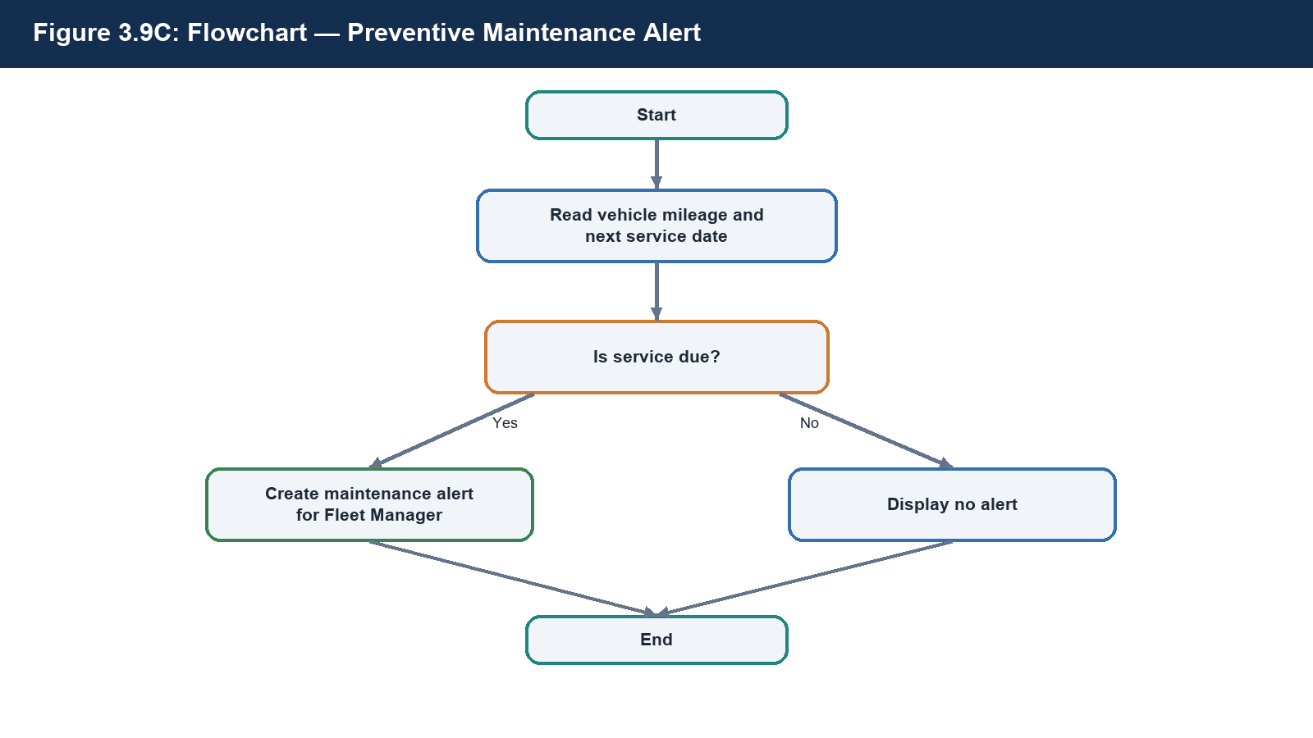
Figure 3.14: Flowchart — Preventive Maintenance Alert

3.9.4 Pseudocode for Delivery Completion
PROCEDURE CompleteDelivery(deliveryID)
BEGIN TRANSACTION
delivery ← find delivery by deliveryID
IF delivery.status ≠ “In Progress” THEN
ROLLBACK; RETURN “Invalid delivery state”
END IF
delivery.status ← “Delivered”
delivery.dateDelivered ← current date/time
delivery.driver.status ← “Available”
delivery.vehicle.status ← “Available”
SAVE delivery, driver, and vehicle
COMMIT TRANSACTION
RETURN “Delivery completed successfully”
END PROCEDURE

3.10 Project Schedule (WBS and PERT/CPM)
System development activities were structured using a formal Work Breakdown Structure (WBS), hierarchically partitioning the engineering project into six discrete work packages:
- 1.0 Project Planning: 1.1 Define project scope and operational boundary; 1.2 Conduct four-part feasibility assessment.
- 2.0 Systems Analysis: 2.1 Formulate functional and non-functional requirements; 2.2 Model Context and Level-0 DFD workflows.
- 3.0 Systems Design: 3.1 Construct Crow's Foot ERD and execute 3NF normalization; 3.2 Specify UML use cases; 3.3 Draft interface screen specifications.
- 4.0 Module Development: 4.1 Implement PostgreSQL DDL schema; 4.2 Develop Flask RESTful backend controller; 4.3 Construct responsive Bootstrap frontend views.
- 5.0 Integration & Testing: 5.1 Execute subsystem module integration; 5.2 Conduct functional verification and acceptance testing.
- 6.0 Documentation & Review: 6.1 Compile technical system write-up; 6.2 Prepare defense presentation slide artifacts.
To establish rigorous project governance and identify critical scheduling dependencies, activities were mapped into a Critical Path Method (CPM) Activity-on-Node network. Forward and backward mathematical passes were executed across all task dependencies:
- Forward Pass Calculation: Early Start (ES) and Early Finish (EF = ES + Duration) were computed sequentially from project inception (Day 0). For convergent tasks (such as Task F: Integration), ES equals the maximum EF among all immediate predecessor tasks: max(EF_D, EF_E) = max(18, 13) = Day 18.
- Backward Pass Calculation: Late Finish (LF) and Late Start (LS = LF - Duration) were computed from the target delivery milestone (Day 30). For divergent task outputs, LF equals the minimum LS among immediate successor tasks.
- Total Slack & Criticality: Total Slack (Float) = LS - ES = LF - EF. Tasks possessing zero slack constitute the Critical Path: A -> B -> C -> D -> F -> G -> H -> I, establishing a minimum total project duration of 30 working days.
Note on Parallel Activity Scheduling: Task E (Frontend Interface Layout, duration = 6 days) depends directly on the finalized system design specifications produced in Task B (EF = 7). Task E runs concurrently alongside database schema setup (Task C) and backend logic development (Task D). Because Task E finishes at Day 13 while downstream integration (Task F) cannot commence until backend logic completes at Day 18, Task E exhibits exactly 5 working days of scheduling slack (LS = 12, LF = 18, Slack = 18 - 13 = 5 days), reconciling the CPM network topology perfectly.
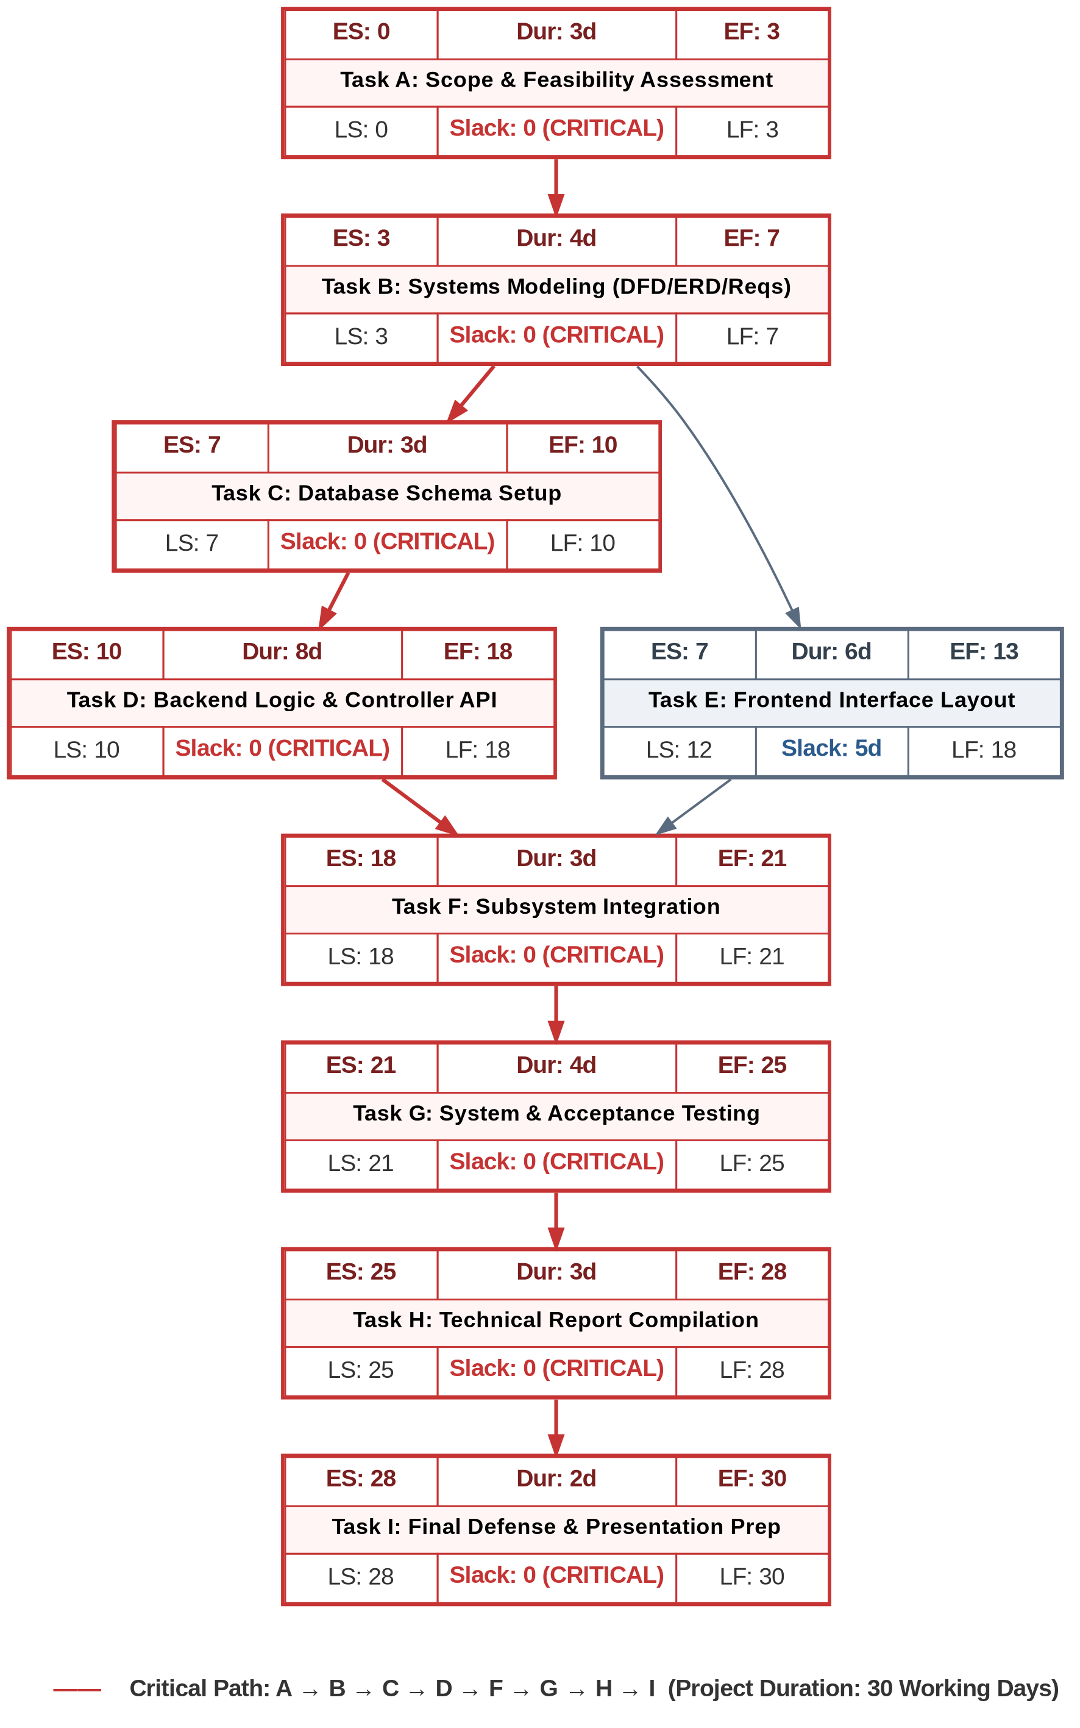
Figure 3.15: PERT/CPM Project Schedule Activity-on-Node Network Diagram

4.0 SYSTEM IMPLEMENTATION AND TESTING

4.1 Development Tools and Technology Stack
The system implementation specification is constructed around a robust, accessible open-source technology stack selected to minimize hosting expenditures while maximizing reliability and developer ergonomics.
Table 4.1: Implementation Technology Stack and Architectural Mapping
Architectural Tier / Layer | Selected Technology & Technical Rationale
Backend Application Framework | Python 3.x with Flask Micro-framework: Lightweight, minimal boilerplate, highly suitable for RESTful endpoints and rapid relational database interactions.
Object-Relational Mapping (ORM) | SQLAlchemy ORM: Bridges application business objects to relational database tables, enforcing validation logic and shielding controllers from raw SQL injection vulnerabilities.
Relational Database Management System | PostgreSQL: Industry-standard open-source relational database engine offering strict ACID transaction compliance, foreign key constraint cascades, and rich data typing.
Client Frontend User Interface | HTML5, CSS3, Bootstrap 5 Framework, JavaScript: Responsive mobile-first design framework guaranteeing operational accessibility across diverse smartphone and desktop browsers.
Cloud Hosting & Deployment Tier | Render / Supabase Community Tier: Zero-cost deployment target providing automated container builds, managed PostgreSQL instances, and native SSL/HTTPS security.
Code Collaboration & Version Control | Git & GitHub: Distributed version control managing software change history, branch isolation, and multi-contributor collaborative development.

4.1.1 Hardware and Software Requirements
The proposed system can operate on ordinary web-enabled devices because processing and persistent storage are hosted centrally. Table 4.2 specifies the minimum environment for development, demonstration, and routine use.
Table 4.2: Hardware and Software Requirements
Component | Minimum Requirement | Purpose
Administrator / Developer Computer | Dual-core 2.0 GHz CPU, 4 GB RAM, 10 GB free storage | Runs browser, editor, local development tools, and documentation.
Driver Mobile Device | Android 9+ or equivalent, 2 GB RAM, modern browser, mobile data | Views assignments and updates delivery status in the field.
Application Host | 1 vCPU, 512 MB RAM, HTTPS-enabled cloud service | Hosts Flask application and business logic.
Database Host | PostgreSQL 14+, 1 GB RAM recommended, daily backup | Stores transactional data with integrity controls.
Network | Stable 3G/4G/Wi-Fi connection for users | Supports secure access to the web application.
Software | Python 3.x, Flask, SQLAlchemy, PostgreSQL, Git, supported browser | Development and runtime software environment.

4.2 Implementation Status
At the milestone of compiling this systems analysis write-up, all Phase 1 and Phase 2 design deliverables—comprising the multi-dimensional feasibility study, requirements determination matrices, balanced Context and Level-0 DFD specifications, normalized 3NF relational schemas, UML use case behaviors, three-tier architectural models, screen inventories, and CPM network schedules—have been fully completed. Physical software code construction against these specifications stands ready for execution, subject to academic session directives from the course examiner regarding live code artifact submissions versus analytical defense requirements.

4.3 Planned Testing Strategy
System verification follows a rigorous four-stage quality assurance protocol designed to ensure that the realized software adheres strictly to all stated functional capabilities and data-integrity rules.
Table 4.3: Planned Multi-Tier Quality Assurance Testing Protocols
Testing Tier | Target Scope, Scope Boundaries & Verification Objectives
Unit Testing | Verifies individual Python route handlers, validation utilities, and SQLAlchemy model methods in total isolation (e.g., asserting that duplicate vehicle registration numbers raise unique constraint integrity errors).
Integration Testing | Validates cross-module interactions and state consistency (e.g., verifying that assigning a delivery order simultaneously updates the vehicle status flag and driver availability status to 'On Delivery' within an atomic transaction).
System Testing | Evaluates the completely integrated web application end-to-end against the formal functional requirements specified in Table 3.2, verifying UI rendering, form submission, and reporting accuracy.
User Acceptance Testing (UAT) | Simulates realistic operational dispatch scenarios with sample SME operational staff to evaluate interface usability, cognitive clarity, and dispatch task execution times under field conditions.
To provide a verifiable benchmark for system validation, Table 4.4 outlines concrete operational test cases covering primary positive workflows, boundary conditions, and negative security constraints.
Table 4.4: Formal System Verification Test Suite & Acceptance Test Cases
Test ID | Scenario Description | Input Test Data | Expected System Output & State Behavior | Status
TC01 | Register New Vehicle Asset | RegNo: 'IBD-452-XY', Make: 'Bajaj', Model: 'Boxer BM150', Type: 'Bike', Odometer: 12500 | Vehicle record saved to database; status initialized to 'Available'; record renders in asset datatable. | Pending Build
TC02 | Valid Delivery Dispatch Assignment | Pending Order ID #101, Available Driver ID #04, Available Vehicle ID #02 | Delivery status transitions to 'In Progress'; Vehicle and Driver statuses update to 'On Delivery' atomically. | Pending Build
TC03 | Resource Conflict Prevention (Negative Test) | Pending Order ID #102, Vehicle ID #02 (currently flagged as 'On Delivery') | Assignment rejected; transaction rolled back; error banner displays: 'Vehicle is currently committed to an active dispatch.' | Pending Build
TC04 | Delivery Lifecycle Completion | In-Progress Order ID #101, Driver confirms delivery completion via mobile view | Order status transitions to 'Delivered'; Vehicle and Driver statuses automatically revert to 'Available'. | Pending Build
TC05 | Preventive Maintenance Log Creation | Vehicle ID #01, Date: '2026-10-15', Desc: 'Engine Oil & Spark Plug Replacement', Cost: 18500 | Maintenance record committed and linked to vehicle; vehicle service history dashboard updates expenditure metrics. | Pending Build

5.0 SUMMARY, CONCLUSION AND RECOMMENDATIONS

5.1 Summary
This project examined the operational vulnerabilities represented by the constructed Case Organisation A scenario and developed a systems analysis and engineering design for a computerised Fleet Management System. A comparative literature review considered established enterprise solutions (Fleetio, Samsara, Verizon Connect, and Concept Nova) and identified a design need for smaller delivery operations. The system design was developed using classical systems development life cycle (SDLC) methods.
The analytical deliverables encompass a four-dimensional feasibility study confirming technical, economic, operational, and schedule viability; an inventory of nine functional capabilities and seven non-functional quality constraints; balanced Gane-Sarson Context and Level-0 Data Flow Diagrams maintaining strict input/output conservation across five data stores; an Entity-Relationship model normalized rigorously from an initial unnormalized relation through 1NF and 2NF to 3NF (resolving composite partial dependencies and intermediate transitive dependencies); a UML 2.5 Use Case model capturing actor boundaries and <<include>> / <<extend>> relationships; a modular three-tier client-server software architecture; seven responsive interface screen specifications; and a PERT/CPM project schedule establishing a 30-day critical path baseline.

5.2 Conclusion
The Case Organisation A scenario indicates that an integrated relational Fleet Management System could address core coordination gaps in a small delivery operation: limited visibility of fleet availability, uncoordinated rider/driver allocation, unclear delivery tracking, and reactive vehicle maintenance. By enforcing database integrity rules and structuring delivery status into auditable stages, the proposed platform is designed to reduce operational guesswork and improve accountability.
The architectural design further suggests that small logistics operations may establish useful administrative control without expensive proprietary telematics hardware. A lightweight web architecture built with Python Flask and PostgreSQL is proposed to provide transactional durability, usability, and auditability at a scale appropriate to the scenario. The design is a blueprint for future construction and evaluation, rather than evidence of a completed deployment.

5.3 Recommendations
Building upon the baseline architecture established in this report, the following progressive technical enhancements are recommended for future development iterations:
- 1. Spatial Tracking: Live GPS Hardware Telematics: Incorporate low-cost IoT GPS tracking modules or driver smartphone background geolocation APIs to render real-time vehicle spatial coordinates on an interactive map overlay.
- 2. Automated Messaging: Automated Multi-Channel Notifications: Integrate SMS and WhatsApp Business webhook APIs (e.g., Twilio or Termii) to deliver automated transit status alerts directly to customers upon dispatch and completion.
- 3. Offline Resilience: Progressive Web Application (PWA) Offline Sync: Enhance the driver mobile interface with service workers and IndexedDB local storage, allowing dispatch riders to log deliveries even in cellular dead-zones with automatic background synchronization upon reconnection.
- 4. Multi-Tenant Expansion: Multi-Branch Tenancy Architecture: Extend the relational database schema with tenant isolation identifiers (BranchID / CompanyID) to support multi-hub delivery enterprises operating across multiple municipal zones.
- 5. Financial Settlement: Integrated Payment Gateway: Connect secure fintech checkout APIs (e.g., Paystack or Flutterwave) to automate delivery fee collection, digital receipt issuance, and instant payment reconciliation.
Operational Recommendation: Prior to production rollout, it is strongly recommended that the delivery enterprise conduct a two-week pilot shadow-run, operating the web portal concurrently alongside existing ledger methods. This transition period will validate field usability, verify rider compliance with mobile status toggles, and refine workshop maintenance categorization under live operational conditions.

REFERENCES
BusinessDay (2026). Concept Nova Unveils Solution to Boost Fleet Management in Nigeria. BusinessDay Media. Available at: https://businessday.ng [Accessed 14 September 2026].
Cartrack South Africa (2026). What Is the Best Fleet Management Software for Small Businesses? Technical White Paper & Industry Report. Available at: https://cartrack.co.za/blog [Accessed 18 September 2026].
GlobalFleet (2026). Nigeria Has New Solution to Boost Fleet Management and Vehicle Telematics. Global Fleet Management Insights. Available at: https://globalfleet.com [Accessed 12 September 2026].
Locate2u (2026). Top 10 Benefits of a Fleet Management System for Small Businesses. Operational Logistics Series. Available at: https://locate2u.com [Accessed 20 September 2026].
Techpoint Africa (2026). Understanding the Challenges and Prospects of Fleet Management and Urban Dispatch in Nigeria. Techpoint Intelligence. Available at: https://techpoint.africa [Accessed 15 September 2026].
Tech.co (2026). Best Fleet Management Software Comparison & Cost Analysis Guide. Tech.co Commercial Reviews. Available at: https://tech.co/fleet-management [Accessed 22 September 2026].
Universal Transit (2026). Exploring the Top 5 Challenges of Managing a Small Commercial Vehicle Fleet. Fleet Operations Journal. Available at: https://universaltransit.com/blogs [Accessed 19 September 2026].
University of Ibadan Distance Learning Centre (2026). CSC 302: System Analysis and Design — Course Study Material and Practical Project Methodology Compilation. Department of Computer Science, Faculty of Science, University of Ibadan.

APPENDIX A: GROUP MEMBER CONTRIBUTIONS
In compliance with CSC 302 course governance directives, this appendix details the specific analytical, modelling, writing, and presentation responsibilities fulfilled by each project group participant.
Table A.1: Project Member Contribution Roster and Deliverable Allocations
Full Name | Matric Number | Project Component & Section(s) Contributed
OLADAPO MARIAM OLAJUMOKE | E051576 | Section 1.0 (Introduction, Problem Statement, Scope & Objectives); System Background Synthesis
ONAOLAPO OYINDAMOLA ELIZABETH | E053414 | Section 2.0 (Literature Review, System Comparison Matrix, Small Fleet Logistical Challenges)
AGADA OLUWADAMILOLA IFEANYI | E054583 | Section 3.1 - 3.4 (Methodology, Feasibility Analysis, Context & Level-0 Data Flow Diagrams)
OLUDARE OWOLABI AMOS | E053430 | Section 3.5 - 3.7 (ER Modeling, 1NF-2NF-3NF Normalization, UML Use Case & 3-Tier Architecture)
[Member 5 Full Name] | E000000 | Section 3.8 - 3.10 (Interface Specifications, Program Design, WBS Decomposition, PERT/CPM Critical Path Calculations)
JIMOH NAFISAT ADEDOYIN | E055107 | Section 4.0 - 5.0 (Implementation Stack, Test Suites, Chapter 5 Summary, Final Review)

